Glenellen Solar Farm

Construction Update

March 2025

With the mechanical work almost complete, the sound of the piling will cease.

Works completed or in progress

|  |  |
| --- | --- |
| * Piling is 100% completed * Substation work has begun (see photo) * Over 80,000 modules (panels) installed * Over 6,700 trackers installed * 38 Inverters have been delivered, more expected in April. * There are currently approximately 150 people working on-site |  |

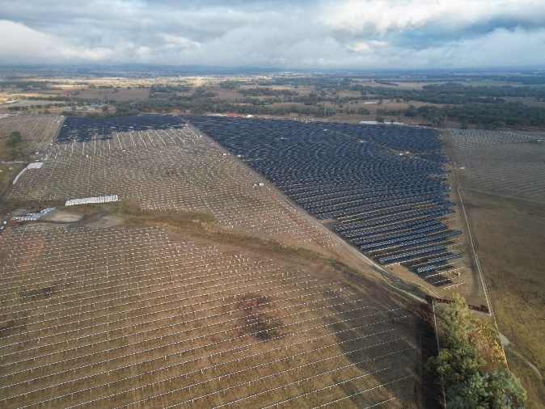

|  |  |
| --- | --- |
|  | Upcoming works on site   * Continue Module and Tracker installation * Civil works on the Transgrid collector sub-station will continue * Landscape screening planting will begin onsite |